ECE/COE 1896

Senior Design

Smart Drone Conceptual Design

Team #4

Prepared By: Karey “KJ” Stone

Seth Nordeen

Berfin Bircan

Cassandra Oliva Pace

[This page is intentionally blank.]

# Table of Contents

Table of Contents i

Table of Figures ii

1. Introduction 1

2. Background 1

3. System Requirements 3

3.1 Detailed Requirements 3

3.1.1 Glove Interface Accuracy *(Required)* 4

3.1.2 Obstacle Detection Response Time *(Required)* 5

3.1.3 Heads-Up Display (HUD) Clarity *(Required)* 6

3.1.4 Display Screen Resolution *(Desired)* 7

3.1.5 Battery Life *(Desired)* 8

3.2 User Workflow 8

4. Design Constraints: Standards and Impacts 9

4.1 Time 9

4.2 Budget 9

4.3 Manpower 10

4.4 Weight 10

4.5 Testing Location 10

4.6 RoHS Compliance 10

4.7 Safety Standards 10

5. Conceptual Design 10

5.1 Hardware Design 12

5.1.1 Glove Hardware 12

5.1.2 Drone Hardware 18

5.2 Software Design 21

5.2.1 Glove Software 21

6. System Test and Verification 23

6.1 Software Systems 23

6.2 Hardware Systems 23

7. Team 23

7.1 Seth Nordeen 24

7.1.1 Skills learned in ECE coursework 24

7.1.2 Skills learned outside ECE coursework 24

7.2 Karey “KJ” Stone 25

7.2.1 Skills learned in ECE coursework 25

7.2.2 Skills learned outside ECE coursework 25

7.3 Berfin Bircan 25

7.3.1 Skills learned in ECE coursework 26

7.3.2 Skills learned outside ECE coursework 26

7.4 Cassandra Oliva Pace 26

7.4.1 Skills learned in ECE coursework 26

7.4.2 Skills learned outside ECE coursework 27

8. Schedule and Budget Plan 27

8.1 Project Schedule 27

8.2 Project Budget 29

8.3 Minimum Standard for Project Completion 30

8.4 Final Demonstration 30

References 31

# Table of Figures

[To update the Table of Contents, Table of Figures, or Table of Tables, click on any text within the table. Press the F9 key on your keyboard (or right click and select “Update Field”). Then select “Update entire table” from the pop-up window and click “OK”. If you use the formatting styles as directed below, your tables will fill automatically and have the correct page numbers.]

*Figure* 1*: MPU-6050 (Gyroscope & Accelerometer) Example Program Output* 4

*Figure* 2*: Flex Sensor Bend Scale* 4

*Figure* 3*: Flow Diagram of Proposed Drone System* 11

*Figure* 4*: NRF24L01+ Module with External Antenna* 13

*Figure* 5*: NRF24L01 Breakout Adapter with a Voltage Regulator* 13

*Figure* 6*: MPU-6050 GY-521(Left) and Circuit Playground Bluefruit (Right)* 15

*Figure* 7*: Flex Sensor with Pins Labeled* 15

*Figure* 8*: ATmega328 Chip and Pin-out* 16

*Figure* 9*:Glove Circuit Schematic* 18

*Figure 10: Hand Motions Diagram* 22

[If necessary, insert a blank page after your Table of Tables to make the front matter end with an even page. You should be able to print your final report double-sided and have the page numbers appear as they would in a book.]

# Introduction

Our innovative smart drone project addresses the limitations inherent in traditional drone systems, specifically focusing on optimizing performance for critical scenarios such as search and rescue operations. Currently, conventional drones are operated using remote controllers equipped with headsets for a first-person view. However, this approach poses challenges for first responders, requiring them to manage both hands for control and potentially obstructing their vision with goggles, leading to motion sickness concerns among users.

To overcome these challenges, our project aims to revolutionize drone control by introducing a glove-based interface, eliminating the need for a traditional remote control that uses both hands. The glove integrates a gyroscope and accelerometer for user input, allowing seamless drone control through intuitive hand movements. This innovative control system encompasses standard drone flight commands, including forward and backward movements, left and right turns, and ascending and descending maneuvers.

To enhance the user experience and address motion sickness concerns, we incorporate a separate 7-inch display screen, providing a clear view without compromising the well-being of the operator. This display not only benefits the user but also allows others to observe the drone's actions. Real-time responsiveness (meaning that the drone will stop when any of the bars turn red, indicating that something is close) is a key feature of our drone, complemented by obstacle detection capabilities displayed through a Heads-Up Display (HUD). The HUD visually informs users if the drone is approaching an object too closely, utilizing colored bars on the screen to represent the distance, with red bars indicating immediate proximity, preventing collisions with obstacles.

The drone's thrusters are controlled by a flex strip on the glove, offering a novel and intuitive mechanism for altitude control. The bending of fingers adjusts the speed of the motors, influencing the drone's flight height - a dynamic and user-friendly feature. To ensure comprehensive awareness, we implemented six sensors distributed across all parts of the drone, eliminating blind spots and contributing to the effectiveness of the HUD program. The core structure of our drone is based on a drone kit that includes essential components such as motors, frame, PID control, and motor control. This kit provides a solid foundation for our drone, ensuring reliability, stability, and performance. Flight stability is further guaranteed through advanced Proportional-Integral-Derivative (PID) control algorithms, enhancing the drone's capacity to operate smoothly and stably in diverse and challenging environments.

In summary, our project offers an innovative solution to the limitations of conventional drones, providing a more user-friendly and effective tool for critical operations performed by first responders. The combination of glove-based control, a separate display, obstacle detection, and PID control algorithms positions our smart drone as a cutting-edge technology for addressing challenges in various operational scenarios.

# Background

In today’s modern 21st century, drones – sometimes referred to as unmanned aerial vehicles – have become extremely popular technological systems that serve many purposes in a wide range of applications within society. From large military-grade drones used in warfare to small hand-held toy drones for children, they come in all shapes, sizes, and with a wide variety of functionalities and gadgets. As mentioned in the introduction section of this paper, most drones are operated using a remote controller that requires the use of both hands to perform the four main drone control movements: roll, pitch, yaw, and throttle. Roll is the rotation around the front-to-back axis of the drone, tilting it to the left or right. Pitch is the rotation around the side-to-side axis of the drone, tilting it forward or backward. Yaw is the rotation around the vertical axis of the drone, pointing the front of the drone in different directions. And throttle controls the altitude of the drone *(“Roll, Pitch, and Yaw | How Things Fly”)*. These four maneuvers are typically performed by controlling two separate joysticks on the remote controller, one for pitch and roll and the other for throttle and yaw. This, therefore, requires the operator to use both hands to control both joysticks. Agility and advanced maneuvers require a combination of precise joystick movements that are not only challenging and associated with a learning curve, but also require a fair amount of concentration from the user. This is not ideal for first responders in critical situations where speed, efficiency, and safety are of utmost importance. Drones have the ability to give first responders a better visual perspective of the emergency scene, whether it is a fire, a search for an endangered person, or a barricaded suspect/hostage situation. But in such cases where adrenaline is high and lives are threatened, requiring a first responder to give a majority of their focus and attention to actually flying a drone can hinder their performance and be the difference between life and death. This problem can be resolved with our glove-based interface, which is far more intuitive than the traditional remote controller. Having the ability to control the drone through simple and natural hand movements eliminates the hassle and learning curve normally associated with traditional remote controllers, and can be more efficient, which matters when time is of the essence. Additionally, since our glove controller only requires one hand to perform all maneuvers, it allows the user to have a free and available hand. This feature might not make a difference to a regular person, but to a first responder in a critical situation, this is absolutely necessary because they are required to relay all information to a dispatch operator and be in communication with fellow first responder personnel on scene, which is done through the use of personal radio devices. Similar to using a walkie-talkie, first responders must press a transmit button on their radio to talk, which requires having a free hand. Having the ability to communicate through their radio at any given moment is crucial for both the first responders’ safety and for the safety of any victims involved on scene. Due to low manpower in first responder units across the country *(Mercer)*, it is not always feasible to have a first responder that can solely focus on controlling a drone because most of the time, all personnel are needed on scene. This makes it imperative to allow a first responder to always have an available hand to use their radio and other vital devices while also maintaining control of the drone.

There are many drones in the market that have a heads-up display feature in the form of goggles that the user can place around their eyes. While this might be desirable for the average user, this would hinder a first responder by obstructing a full range view, which can be dangerous in critical scenarios such as a barricaded suspect situation where the actions and position of the suspect might be unknown, and first responders must be on full alert and be able to anticipate an attack from any direction. This makes our separate heads-up screen display desirable for first responders since it allows a first-person view from the drone without compromising their safety and also avoiding the possibility of motion sickness from using goggles. In critical scenarios where the safety of the people involved in the situation takes precedence and the drone is there only to enable first responders to be more efficient in resolving any problems, it is important that the drone come equipped with safety mechanisms that prevent it from being more hindering than beneficial. This is why the obstacle detection and avoidance features integrated into our heads-up display gives a great advantage to first responders. In time-sensitive scenarios, first responders cannot afford to worry about whether or not the drone will accidentally crash if they focus their attention more on the current situation in front of them rather than on carefully flying the drone. This makes obstacle detection and avoidance an important feature to maximize efficiency, and the useful warning feedback given through audio and visual cues in the heads-up display allows first responders to see the approximate distance from the drone to any surrounding objects so that quick and accurate adjustments can be made to the position of the drone. Although drones with single-hand controllers, screen displays, or obstacle detection and avoidance features can currently be found on the market, it is difficult to find a drone that integrates all of these attributes together into one system. This makes our smart drone unique and tailored to first responders, particularly for critical and dangerous scenarios. While drones are currently used in particular search and rescue operations, firefighting, and sometimes law enforcement, they are not used nearly as often as they could be due to the inherent obstacles that first responders must overcome when using traditional drones, as has been explained. This presents a niche in the market for our smart drone.

In order to understand the implementation of our design, it is important to first understand a few key concepts regarding the functionality of some of the hardware components we will utilize. As briefly mentioned in the introduction section of this paper, a gyroscope and accelerometer will be integrated into the glove controller for user input. They detect direction and motion to then control the movement of the drone. Though similar in purpose, these two sensory devices measure different things. A gyroscope is a device that uses Earth's gravity and key principles of angular momentum to help determine orientation, while an accelerometer measures linear non-gravitational acceleration based on vibration *(Goodrich)*. A sensor chip that combines both a gyroscope and accelerometer will be used for the glove controller, enabling precise motion tracking and reduced risk of errors. For the implementation of obstacle detection and avoidance, distance sensors, particularly time-of-flight sensors, will be integrated onto the drone itself. Time-of-Flight (ToF) sensors measure distance by using the time that it takes for photons to travel between two points, from the sensor’s emitter to a target and then back to the sensor’s receiver *(Admin_TeraBee)*. Using these measurements, feedback regarding the relative distance from the drone to surrounding objects can be given to the user, warning them if the drone is too close to an object and subsequently overriding the user’s commands so that the drone is forced to stop, and a collision is avoided. The way that hardware components internally function determines the way that our design and algorithms are implemented to produce our smart drone prototype, as will be explained in more detail throughout the remainder of this document.

# System Requirements

In the development of a drone control system, it is imperative to establish precise design requirements to ensure optimal performance and user experience. This section outlines critical requirements for glove interface accuracy, obstacle detection response time, and heads-up display (HUD) clarity, as well as desirable features like display screen resolution and extended battery life.



## Detailed Requirements

### 3.1.1 Glove Interface Accuracy *(Required)*

**Detail:** The glove-based interface serves as the primary means of drone control, demanding a high degree of accuracy in interpreting hand movements to ensure a seamless and responsive user experience. The system must accurately capture and translate various hand gestures, including rotations, tilts, and finger flexions, into corresponding drone commands. Precision is paramount, with an allowable error margin not exceeding ±5 degrees for angular movements and ±2 degrees for finger flexion. *Figure 1* shows an example program output for the chosen gyroscope and accelerometer.

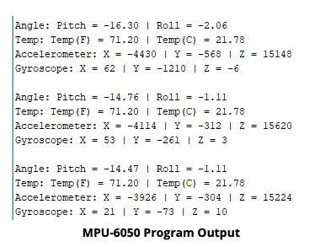

*Figure* 1*: MPU-6050 (Gyroscope & Accelerometer) Example Program Output*

The glove interface should also effectively interpret signals from flex sensors to modulate the drone motor speed, with an acceptable error rate of no more than ±3% in speed adjustments. Calibration mechanisms should be implemented to account for individual variations in hand size and shape, ensuring a universally accurate and user-friendly control system. *Figure 2* below shows the difference in resistance for various degrees of flex. *(ARDUINO TEAM; “Flex Sensor”; “MPU-6050 GY-521 3-Axis Accel & Gryo Sensor Module”)*

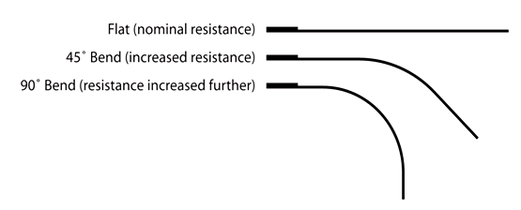

*Figure* 2*: Flex Sensor Bend Scale*

This accuracy requirement is fundamental to achieving precise and intuitive drone maneuvers, enhancing both user satisfaction and flight performance.

**Justification:** Precision in hand gesture recognition is pivotal for the overall effectiveness and success of the drone control system, particularly in critical operations performed by first responders. In scenarios where split-second decisions and precise maneuvers are imperative, the accuracy of the glove interface becomes a critical factor. First responder operations often demand quick and adaptive drone movements to navigate through complex environments, identify points of interest, and deliver aid efficiently. The ±5 degree allowable error for angular movements ensures that the drone responds accurately to subtle hand gestures, facilitating precise navigation and avoiding potential obstacles with a high level of confidence. Additionally, the need for seamless and intuitive control is heightened as operators focus on the mission at hand rather than wrestling with the control interface. A ±2 degree error for finger flexion, combined with effective interpretation of flex sensors, ensures that speed adjustments are finely tuned, allowing the drone to navigate safely through confined spaces or adjust its speed dynamically as the situation requires. Therefore, the stringent precision requirements established for hand gesture recognition directly contribute to the system's reliability, user satisfaction, and ultimately the success of critical operations.

### 3.1.2 Obstacle Detection Response Time *(Required)*

**Detail:** The drone's obstacle detection system is a critical safety feature that demands real-time responsiveness to ensure the immediate identification and avoidance of obstacles in its path. The system must be designed to detect obstacles within milliseconds, providing instantaneous feedback to the drone's control system. In practical terms, this implies that the obstacle detection algorithm should operate at a speed that allows the drone to recognize and respond to obstacles within a maximum time frame of 50 milliseconds. Upon detection, the drone must take prompt action, initiating an immediate halt and overriding user commands if an obstacle is deemed too close for safe navigation. This response time is essential, particularly in dynamic environments where obstacles can emerge unexpectedly. The system's ability to operate within this stringent time frame ensures that the drone can swiftly adapt its trajectory to avoid collisions, safeguarding both the drone and the surroundings. The overriding mechanism adds an extra layer of safety, prioritizing obstacle avoidance over user input in critical situations. This requirement aligns with industry standards for safe drone operations and enhances the overall reliability and safety of the drone control system, making it suitable for diverse applications, including urban navigation and confined-space operations.

**Justification:** The quick and accurate detection of obstacles is paramount for the overall safety and success of drone operations. In a range of applications, from urban environments to confined spaces, the drone's ability to swiftly identify obstacles directly correlates with its capacity to navigate effectively and avoid collisions. Rapid obstacle detection within milliseconds serves as a crucial safeguard, significantly reducing the risk of accidents and potential damage to the drone, nearby structures, or people. In scenarios like urban navigation, where drones may encounter dynamic and unpredictable obstacles, such as moving vehicles or pedestrians, the immediate response time ensures that the drone can make split-second decisions to alter its course and prevent accidents.

Furthermore, in applications like search and rescue or disaster response, where drones are deployed in challenging and potentially hazardous environments, the ability to quickly detect obstacles is instrumental. It allows the drone to navigate through complex terrains or structures without compromising the safety of responders or individuals in need of assistance. The real-time responsiveness of the obstacle detection system also mitigates the risk of the drone inadvertently colliding with obstacles during critical operations, ensuring a higher level of operational safety and mission success.

In essence, the requirement for obstacle detection with rapid response time aligns with industry safety standards, enhances the reliability of the drone control system, and safeguards the drone, its surroundings, and the individuals involved in the operation, reinforcing its suitability for diverse and safety-critical applications.

### 3.1.3 Heads-Up Display (HUD) Clarity *(Required)*

**Detail:** The Heads-Up Display (HUD) serves as a critical component of the drone control system, and its clarity is essential for effective user interaction. Specifically, the HUD must provide clear and intuitive visual cues representing obstacle proximity. To achieve this, the display will utilize colored bars that dynamically adjust based on the distance between the drone and obstacles in its path. Each colored bar will correspond to a specific range of distances, allowing the user to quickly and accurately assess the proximity of obstacles. For instance, green bars may indicate a safe distance, yellow bars a cautionary range, and red bars an imminent collision zone. The HUD must be designed to update in real-time to reflect changes in obstacle proximity, ensuring that users receive instant and accurate feedback on potential collision risks. Additionally, the clarity requirement extends to the size, placement, and contrast of the bars to guarantee visibility in various lighting conditions. By providing a visually intuitive representation of obstacle distances, the HUD contributes to user situational awareness, enabling precise control and enhancing overall safety during drone operations.

**Justification:** A clear and easily understandable Heads-Up Display (HUD) is indispensable for real-time decision-making during drone operations, where split-second judgments are crucial for successful navigation and obstacle avoidance. The use of colored bars to represent obstacle proximity enhances the user's ability to rapidly interpret critical information, providing an immediate and intuitive visual reference for the drone's surroundings. The utilization of colors, such as green, yellow, and red, offers a quick and discernible coding system, enabling users to assess the level of risk associated with obstacles at a glance. Green signifies a safe distance, yellow alerts the operator to exercise caution, and red signals an imminent collision zone. This color-coded scheme serves as a rapid visual cue that is universally understood, minimizing the cognitive load on the user, and facilitating quick decision-making in dynamic and complex environments.

The real-time updating feature of the HUD ensures that the information presented is continuously aligned with the drone's changing surroundings. This dynamic feedback allows users to adapt their control inputs based on the evolving proximity to obstacles, fostering a heightened sense of situational awareness. In high-stakes scenarios, such as emergency response or urban navigation, where obstacles can emerge unexpectedly, the clarity of the HUD becomes a decisive factor in preventing collisions and ensuring the safety of both the drone and its surroundings. The intuitive representation of obstacle distances through colored bars not only enhances operational safety but also contributes to the overall user experience, enabling operators to focus on mission objectives without being encumbered by complex data interpretation. Therefore, the requirement for a clear and visually informative HUD is fundamental to optimizing user decision-making and ensuring the success of drone operations across diverse and dynamic environments.

### 3.1.4 Display Screen Resolution *(Desired)*

**Detail:** The desire for a high display screen resolution is rooted in the goal of delivering an immersive and informative visual experience for both the drone operator and any potential observers. The display screen should boast a resolution that ensures the crisp and clear rendering of visuals, facilitating detailed observation and precise control. A high-resolution screen is essential for presenting live video feeds, telemetry data, and the Heads-Up Display (HUD) with exceptional clarity. This not only enhances the operator's ability to discern fine details during drone operations but also provides observers with a more comprehensive and visually engaging perspective of the drone's surroundings.

Moreover, the desire for high display screen resolution aligns with the increasing demand for visual data in various applications, including first responder operations. The ability to capture and relay high-quality visuals in real-time contributes to mission effectiveness and ensures that critical information is conveyed accurately to both the operator and any people involved. Additionally, a high-resolution display screen supports a future integration of advanced features, such as digital zoom and image enhancement, further extending the capabilities of the drone control system. In essence, this desire for elevated display screen resolution aims to maximize the informational value of the visuals presented, fostering an enhanced user experience and bolstering the utility of the drone control system across a spectrum of applications.

**Justification:** While not inherently essential for basic functionality, the desire for a higher resolution display screen stems from the recognition that enhanced visual clarity significantly contributes to the overall user experience for both operators and observers of the drone control system. The increased resolution goes beyond merely meeting functional requirements; it elevates the system's capabilities, providing tangible benefits that resonate throughout various operational scenarios. For operators, a higher resolution display translates to a more detailed and discernible view of the drone's environment. This is particularly crucial in situations where precision is paramount, such as when navigating through intricate or densely populated areas. The improved visual fidelity allows operators to make more informed decisions based on finer details, contributing to a higher level of control and confidence during drone operations.

From the perspective of observers involved in the operation, a higher resolution display enhances their ability to comprehend the live video feeds and telemetry data transmitted by the drone. This is especially relevant in collaborative or monitoring scenarios where multiple individuals may be interpreting the visuals simultaneously. Clearer visuals facilitate better communication and understanding among team members, leading to more effective collaboration and decision-making. Furthermore, the desire for a higher resolution display positions the drone control system to accommodate future advancements in visual technologies. As drone applications continue to evolve, the ability to support and leverage higher resolution displays ensures that the system remains adaptable and capable of delivering a state-of-the-art user experience. In summary, while not strictly essential for basic functionality, the desire for a higher resolution display screen reflects a commitment to optimizing the user experience, improving decision-making capabilities, and future-proofing the drone control system for emerging visual technologies and applications.

### 3.1.5 Battery Life *(Desired)*

**Detail:** The desire for extended battery life is a pivotal consideration for both the drone and the glove-based control system, aiming to maximize operational time and overall system efficiency.

**Drone Battery Life:** The drone's battery life directly impacts its mission endurance and operational capabilities. Aiming for extended battery life is crucial for prolonging flight durations, especially in applications such as search and rescue where extended flight times enhance mission coverage and effectiveness. An extended drone battery life reduces the need for frequent landings and recharging, increasing the efficiency of operations and reducing downtime. Additionally, it allows the drone to cover larger areas, monitor events for extended periods, or travel greater distances without the constraint of frequent battery changes.

**Glove-Based Control System Battery Life:** For the glove-based control system, an extended battery life is equally significant. The control system should be designed to support prolonged usage without requiring frequent recharging, ensuring uninterrupted operation during critical tasks. This is particularly crucial in scenarios where the operator needs to maintain continuous control over the drone for extended periods. The extended battery life for the glove enhances user experience, providing a reliable and sustained interface for controlling the drone without interruptions. It also reduces the logistical burden on operators, enabling them to focus on the mission at hand without frequent breaks for recharging.

**Justification:** The desire for extended battery life for both the drone and the glove-based control system stems from the recognition that operational efficiency and mission success hinge on prolonged, uninterrupted usage. In applications where continuous surveillance, prolonged flight missions, or extended control sessions are imperative, extended battery life becomes a critical factor. It directly contributes to enhanced productivity, reduced operational constraints, and an overall improvement in the drone control system's effectiveness. By aiming for extended battery life, the system becomes more versatile, adaptable to a variety of applications, and better equipped to meet the demands of diverse and dynamic operational scenarios.

By clearly outlining these detailed requirements and distinguishing between critical features and desirable enhancements, the group can focus on meeting the essential needs of the customer while also considering potential improvements for a more comprehensive and user-friendly system.

## User Workflow

* **Wearing the Glove:** The user wears a specially designed glove equipped with sensors, ensuring a snug fit for accurate hand movement capture.
* **Powering Up the System:** Turn on the drone, the display screen, and the glove interface, ensuring that all components are powered up and ready for operation.
* **Calibration:** Calibrate the glove system to ensure precise correlation between hand movements and drone commands. The glove will light up along with the drone to indicate a connection.
* **Take-Off and Landing:** Use the flex sensor on the glove's pointer finger with driving hand in stationary mode to activate the thrusters to make the drone ascend or descend.
* **Monitoring with Display Screen:** Use the 7-inch display screen to monitor the drone's actions in real-time, allowing for clear visibility without the need for additional goggles.
* **Gesture-Based Control:** Control the drone's flight through intuitive hand movements, including forward and backward motions, left and right turns.
* **Obstacle Awareness:** Rely on the Heads-Up Display to receive visual cues about the drone's proximity to obstacles, using the colored bars to gauge the distance and prevent collisions.
* **Emergency Response:** In case of emergencies or critical situations, the drone will quickly stop and override the user’s commands.
* **Shutdown Procedure:** Safely power down the drone and associated components after completing the mission.

This user-friendly workflow aims to provide first responders with a seamless and effective tool for critical operations, ensuring the safety and well-being of both operators and potential victims. (ARDUINO TEAM; Click Science)

# Design Constraints: Standards and Impacts



## Time

As in industry, we only have a limited amount of time in which we must complete this project. We are limited to one semester to design, fabricate, and test our proposed drone system. This time restraint also affects what parts we can utilize because we must account for shipping time and stock. We must use parts that are in stock because any other parts will not come in time. We plan to use a rigorous team schedule to help with the constraint of time ensuring that we meet our final goal within the allotted time.

## Budget

As with industry, we have a set budget to complete our project. Typical drones used for this project cost on average $3000 to $5000. These drones do not possess the obstacle detection and avoidance that we will be creating with our project. We are also limited to a $200 budget for this project which severely limits our options as a basic drone costs around $250. We are expected to design our control and sensor integration within the allotted budget, although we have been approved for a justified increase in budget given the nature of our system.

## Manpower

Since our group is composed of only four team members, each member is responsible for a significant portion of work. We must ensure that we are in constant communication throughout the semester and that we all have the same understanding of how our design is to be implemented. We must also ensure that we are working diligently to not fall behind our schedule to meet our desired outcome within the allotted time constraint.

## Weight

Our drone must be less than 55 pounds to be considered for recreational use by PA drone laws. This allows us to use the drone without the need to register the drone with the FAA, broadcast a personal call sign, or get a drone license. This ensures that we can test our design without the need for any of our team members to pay to get a drone license.

## Testing Location

Due to federal and airspace laws regarding restricted areas where unmanned aerial vehicles cannot be flown, the locations where we will be able to fly and test our drone are limited. The area surrounding Oakland is controlled airspace and a restricted zone due to the various hospitals and stadiums. This means we will have to travel outside of the city to fly the drone in the air, potentially restricting the extent of our system testing and verification.

## RoHS Compliance

Even though there is no plan to use our drone system in the EU, we still want our project to meet RoHS standards for hazardous materials. RoHS standards restrict the levels of materials such as Lead, Mercury, Cadmium, and multiple other hazardous and toxic materials to safe limits. To ensure compliance with these standards, all of the parts that we will be using for our drone system are RoHS compliant thus ensuring our final design will also be RoHS compliant.

## Safety Standards

We must follow PA drone safety laws including but not limited to, keeping the drone within visual distance of the operator, giving way to, and staying out of the way of other aircrafts, flying at or below FAA-authorized altitudes, and taking and carrying proof of completion of the TRUST safety test. This limits our ability to test our project so that we comply with FAA and PA drone laws.

# Conceptual Design

Apart from the conventional user expectations when flying a drone, such as stability and movement control, our proposed drone system has three additional functions that are particularly beneficial for first responders in critical scenarios. These three functionalities include the ability to control the drone through natural and intuitive hand movements when wearing a glove on one hand, the ability to have a first-person view from the drone displayed in real time on a screen, and the ability to rely on safety mechanisms such as obstacle detection and avoidance on the drone. These three functions and the interacting elements of the system can be visualized by referring to the flow diagram below in figure 3. In the figure, the glove controller, display screen, and drone itself are separated as three different elements of the system. Beginning with the glove controller, a gyroscope, accelerometer, and flex sensors detect the user’s desired control movements, which are then read and interpreted by a microcontroller and sent to a radio module that transmits the information to the drone. Another radio module on the drone itself then receives this information, which is interpreted by another microcontroller on the drone and sent to the flight controller. Distance sensors on the drone are responsible for obstacle detection and avoidance, so they communicate with both the microcontroller and flight controller to give the user audio and visual feedback of relative distance to surrounding objects and command the drone to stop when collision risk is high. A camera mounted on the drone streams live feed to a separate screen near the user, providing a first-person view and a heads-up display with visual cues of the approximate distance to surrounding objects.

*Figure* 3*: Flow Diagram of Proposed Drone System*

This proposed drone system and its functionalities have been divided into four separate modules, one assigned to each team member. These modules consist of the glove hardware, glove software, drone/screen hardware, and drone/screen software.

## Hardware Design

### 5.1.1 Glove Hardware

Our glove-based control system is a pivotal component of our innovative smart drone project. The hardware design for the glove encompasses several key elements that contribute to intuitive and precise control. Here's an overview of the essential components, along with viable options and details on their implementation:

**Radio Transmitter:**

The glove incorporates a radio transmitter to establish communication with the drone. This allows for real-time control and responsiveness during drone operations. There were two models that we were interested in, both were NRF24L01+ Modules. One module has an antenna, and the other does not. More specific details are included below.

*NRF24L01+ Module with External Antenna:*

**Pros:**

* **Extended Range:** In outdoor environments or situations where the drone may operate at a significant distance, the external antenna can provide a more reliable and extended communication range.
* **Signal Quality:** External antennas can help mitigate signal interference, providing a more stable connection during drone control.
* **Flexibility:** If the drone is expected to operate in various conditions, the flexibility to switch antennas for optimal performance can be advantageous.

**Cons:**

* **Bulk:** The external antenna may add some bulk to the glove, potentially affecting its ergonomics.

*NRF24L01+ Module without External Antenna:*

**Pros:**

* **Compact Size:** Modules without external antennas are more compact, which can be beneficial for the form factor and comfort of the glove.

**Cons:**

* **Limited Range:** In environments with obstacles or interference, the range of the module without an external antenna may be more constrained.

Since the drone is expected to operate in crowded areas or at a distance, the external antenna is likely to be more beneficial for maintaining a reliable connection. We are prioritizing a stable and reliable signal, especially if precise control is crucial for drone maneuvers. If the radio transmitter is placed in a way the antenna comes up from the finger it will not hinder the natural movement of the hand or interfere with the glove’s ergonomics and the user’s comfort. The external antenna provides flexibility for expansion or changes in operational conditions. In general, considering the specific use case of a glove controlling a drone, a module with an external antenna *(Figure 4)* may be more suitable for ensuring reliable and extended communication range.

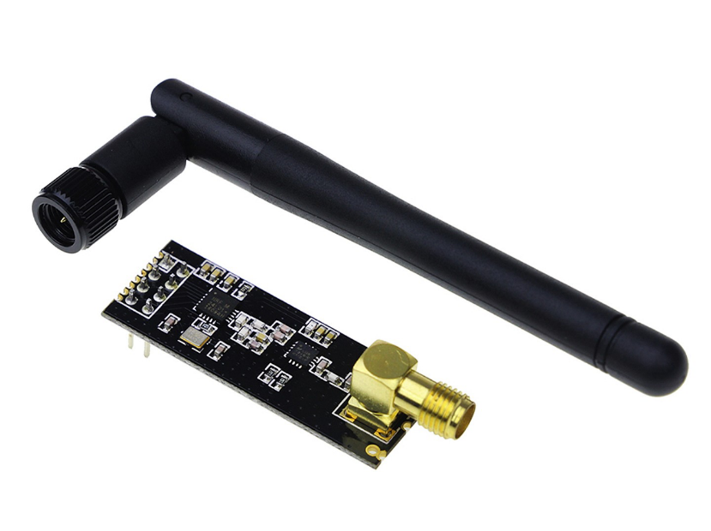

*Figure* 4*: NRF24L01+ Module with External Antenna*

The next step would be integrating an nRF24L01 Breakout Adapter with Voltage Regulator *(Figure 5)* into the radio transmitter to enhance the overall functionality and reliability of the system. This breakout adapter serves as a crucial go-between, simplifying the connection of the NRF24L01+ module to the transmitter circuit. The built-in voltage regulator ensures stable and consistent power supply, adhering to the NRF24L01+'s specific power requirements. By incorporating this adapter, potential issues related to power fluctuations are mitigated, contributing to the module's optimal performance. Additionally, the breakout adapter streamlines the wiring process, making it more accessible to interface with the microcontroller we are using. (“NRF24L01 Breakout Adapter with Voltage Regulator”; “NRF24L01+PA+LNA 2.4GHz RF Wireless Module”)

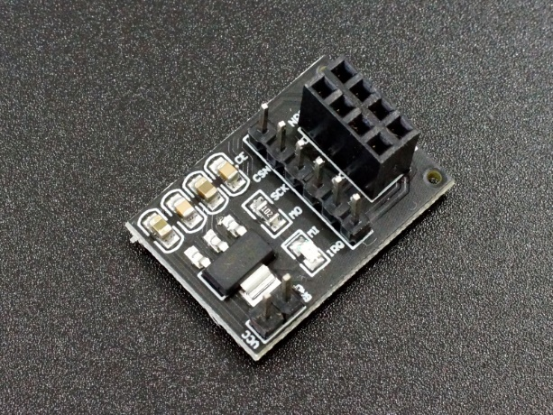

*Figure* 5*: NRF24L01 Breakout Adapter with a Voltage Regulator*

This combination of the NRF24L01+ module and the breakout adapter not only facilitate seamless communication with the drone but also enhances the transmitter's robustness, ensuring a reliable and responsive link between the glove-based control system and the smart drone.

**Gyroscope & Accelerometer:**

The glove incorporates both a gyroscope and an accelerometer to precisely capture hand movements. When deciding between a conventional option like the MPU-6050 GY-521 3-Axis Accel & Gyro Sensor Module and a more dynamic choice such as the light-up Circuit Playground Bluefruit, considerations revolve around factors like power consumption, precision needs, and user interface preferences. The gyroscope/accelerometer component plays a pivotal role in transforming hand gestures into effective control commands for the drone, making it a key element in the overall functionality of the glove-based control system.

*Regular Gyroscope/Accelerometer (MPU-6050 GY-521):*

**Pros:**

* **Accuracy:** Provides accurate orientation data, essential for fundamental control needs.
* **Power Efficiency:** Generally, regular gyroscopes like the MPU-6050 are designed to be power-efficient.
* **Precision:** Offers precise control over hand movements, critical for drone control.

**Cons:**

* **Visual Feedback:** Lacks a visual element to enhance user experience and provide tangible representation of hand movements.

*Light-up Gyroscope/Accelerometer (Circuit Playground Bluefruit):*

**Pros:**

* **Visual Element:** Introduces an additional visual element, enhancing user experience by providing a tangible representation of hand movements. *Figure 6* shows the component fully lit up beside the regular gyroscope and accelerometer.
* **User Engagement:** Adds an interactive dimension to the control system, potentially increasing user engagement.
* **Customization:** May allow for customization of visual feedback, contributing to a more immersive control experience.

**Cons:**

* **Power Consumption:** Typically, light-up components consume more power compared to standard gyroscopes.
* **Precision:** Has lower precision compared to dedicated IMUs like the MPU-6050.

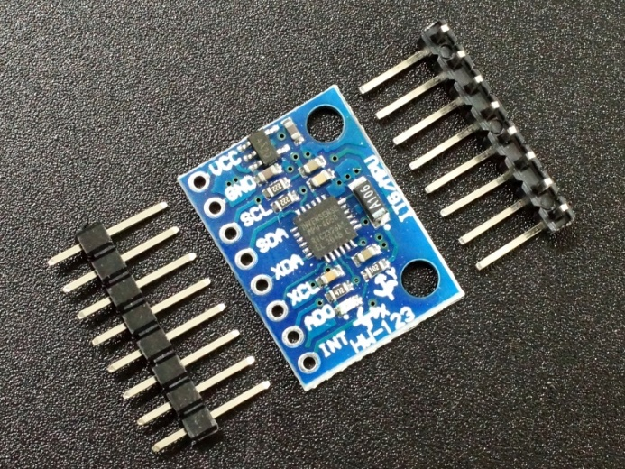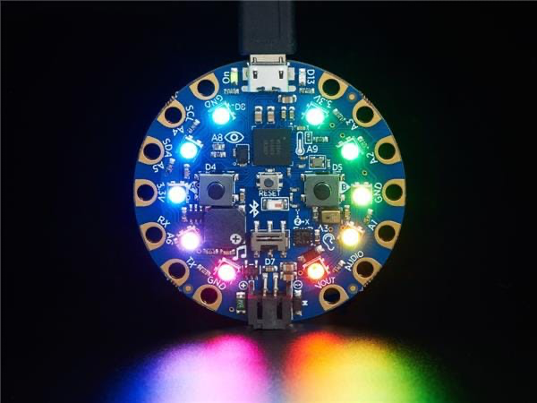

*Figure* 6*: MPU-6050 GY-521(Left) and Circuit Playground Bluefruit (Right)*

Given our emphasis on achieving precise control over hand movements for drone maneuvers, the MPU-6050 regular gyroscope/accelerometer emerges as the best choice. The limited space within the glove, consequently restricting the available voltage due to size constraints, emphasizes the significance of power efficiency in our decision-making process. Notably, the light-up gyroscope/accelerometer necessitates a higher operating voltage compared to its regular counterpart, and opting for the non-illuminated version is consistent with a more professional aesthetic. The regular gyroscope/accelerometer *(Figure 6)* is anticipated to outperform the light-up variant in terms of precision, sensitivity, and response time essential for our drone control system. In summary, the deliberate choice in our smart drone control system leans towards the regular gyroscope/accelerometer to meet our specific requirements effectively. (“Circuit Playground Bluefruit: Advanced Bluetooth LE Microcontroller for DIY Projects”; “MPU-6050 GY-521 3-Axis Accel & Gryo Sensor Module”)

**Flex Sensor:**

The glove design incorporates a flex sensor to enhance the drone control experience, particularly for adjusting the thrusters. This sensor is responsive to finger bending, enabling users to dynamically modulate the drone's motor speed and influence its flight height. When selecting the appropriate sensor length, it is crucial to align it with the user's finger length for optimal responsiveness. That is why when selecting the appropriate flex sensor length, we opted for a 3-inch variant, aligning with the typical finger length. These sensors detect bending in a single direction, essentially functioning as resistors that alter their value based on the degree of flexion. When unflexed, the resistance hovers around ~10KΩ, increasing to ~20KΩ when fully flexed. Comparable to Force-Sensitive Resistors (FSRs), utilizing these flex sensors involves techniques covered in tutorials. Integration can be achieved through an analog input on a microcontroller (with a pullup resistor). (“Flex Sensor”; Jimblom)

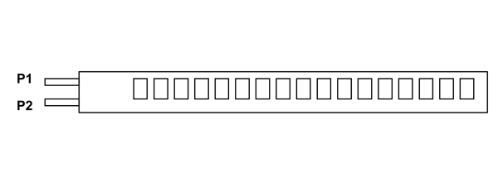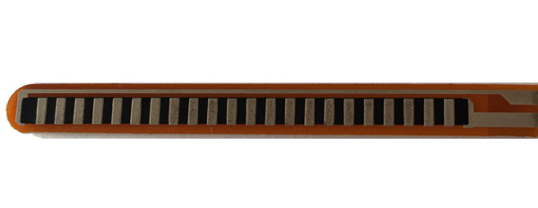

*Figure* 7*: Flex Sensor with Pins Labeled*

It's also important to note that the lower part of the sensor, where the pins are crimped on (shown in *Figure 7*), is delicate. To prevent damage to the contacts, we are implementing strain relief measures, such as clamping or gluing.

**Microcontroller (ATmega328 Chip):**

The microcontroller, powered by the ATmega328 chip, serves as the central processing unit within the glove-based control system. Responsible for connecting and orchestrating all components, it interprets signals generated by the gyroscope and flex sensor. This microcontroller efficiently processes user input and subsequently communicates the corresponding commands to the drone via the integrated radio transmitter. In *Figure 8* the through hole version of the chip is shown along with the labeled pin-out. (“ATMega328P Microcontroller Pinout, Pin Configuration, Features & Datasheet”)

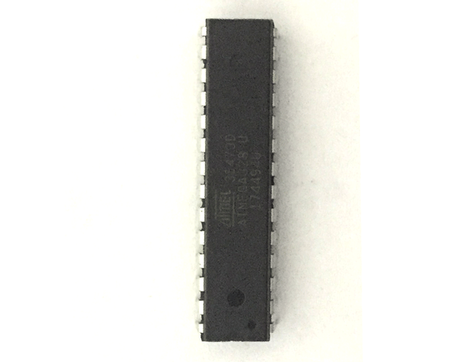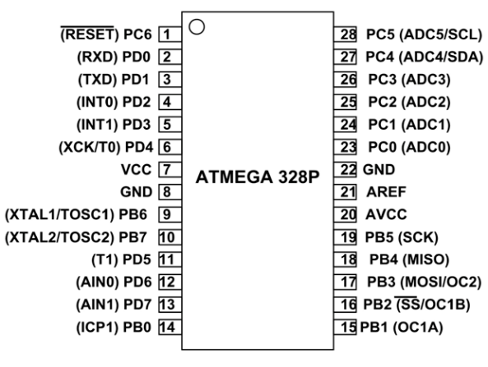

*Figure* 8*: ATmega328 Chip and Pin-out*

In essence, the ATmega328 chip plays a pivotal role in seamlessly managing the integration and communication of various elements within the glove, ensuring precise and responsive control over the drone.

**LED Indicator:**

Incorporated into the glove design is an LED indicator that visually communicates the connection status between the glove and the drone, ensuring the operator stays informed about the system's operational state. This LED can exhibit various colors or patterns to convey specific information, including indicators for connection establishment, signal strength, or low battery warnings. The decision regarding whether to use through-hole LEDs (TH LED) or surface-mount device LEDs (SMD LED) for this indicator in our glove-based control system requires careful consideration of design preferences, assembly methods, and the specific demands of the application.

*Through-Hole LED:*

**Pros:**

* **Ease of Assembly:** TH LEDs are generally easier to handle and solder during the assembly process, making them suitable for manual soldering or prototyping.
* **Durability:** They often exhibit better mechanical stability and durability due to the robust through-hole connections.

**Cons:**

* **Size and Space:** TH LEDs may be larger and can consume more space on the PCB, which could be a concern for compact designs.
* **Limited Variety:** The variety of colors and styles available in through-hole LEDs might be somewhat limited compared to SMD LEDs.

*Surface-Mount Device LED:*

**Pros:**

* **Compact Size:** SMD LEDs are smaller, allowing for more flexibility in design, especially in space-constrained applications.
* **Versatility:** They come in a wide variety of colors, styles, and configurations, providing more options for customization.

**Cons:**

* **Soldering Challenges:** SMD LEDs can be more challenging to solder manually, requiring specialized equipment or techniques.
* **Mechanical Durability:** They may be slightly less mechanically robust compared to through-hole LEDs.

When designing the glove, space efficiency is paramount, leading us to favor Surface Mount Device (SMD) LEDs due to their compact size. While manual soldering and prototyping pose additional challenges for SMD LEDs compared to through-hole LEDs, the advantages outweigh the complexities. SMD LEDs not only provide a more extensive array of colors and styles, aligning with our customization requirements, but they also contribute to a sleeker and less cumbersome profile on the glove. This consideration shows the reasoning for our decision to opt for SMD LEDs, prioritizing both spatial constraints and visual customization in the design process.

**Power Supply:**

The glove is powered by a 9V battery as its power source, delivering a dependable and portable energy solution for the entire system. The power supply holds significant importance, guaranteeing consistent and steady operation, especially in critical situations like search and rescue missions. To meet these requirements, we opted for a rechargeable battery that is both lightweight and compact. To maximize battery life during use, we incorporated an efficient power management system into the design, utilizing the nRF24L01 Breakout Adapter with Voltage Regulator. This rechargeable battery ensures a sustainable and cost-effective power solution for the glove-based control system.

**Ergonomic Design:**

to enhance user comfort and facilitate effective control. In the selection of materials, prioritizing flexibility and breathability is crucial for extended periods of use. Our choice of an airsoft glove not only met these criteria but also proved cost-effective, considering budget constraints arising from the drone kit expenses. The decision was influenced by a group member's unused set, indicating both availability and user satisfaction. Emphasizing a robust construction was a priority to withstand diverse environmental conditions, particularly in contexts such as search and rescue missions where durability is paramount.

**Overall Connection and Functionality:**

In the seamless operation of the glove-based control system, the gyroscope and flex sensor work collaboratively to deliver real-time hand movement data to the microcontroller. The microcontroller, an ATmega328 in this setup, processes the received data and generates corresponding commands. Subsequently, the nRF24L01 radio transmitter, connected to the ATmega328 digital pins PB1-PB5, facilitates the transmission of these commands to the drone, ensuring an immediate response. Concurrently, an LED indicator, linked to the ATmega328 digital pin PD1, communicates the connection status and offers crucial feedback to the operator. The power supply, managed through careful connections between the components and the ATmega GND and VCC pins, guarantees sustained operation, while the nRF24L01 Breakout Adapter with Voltage Regulator enhances the efficiency of the overall communication process.

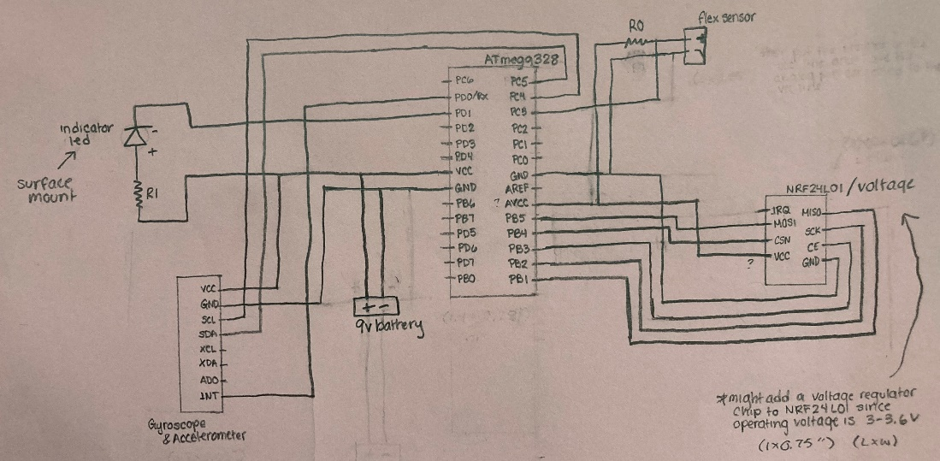

*Figure* 9*:Glove Circuit Schematic*

Additionally, the gyroscope/accelerometer and flex sensor are intricately connected to the ATmega analog pins PC5, PC4, and PC3, respectively, with associated pull-up resistors and power connections, contributing to the comprehensive functionality of the glove-based control system. The seamless integration of these hardware components enables a user-friendly and effective glove-based control interface, addressing the limitations of traditional remote controllers in drone operations. *Figure 9* included above shows the pin-out visually. This design ensures precision, responsiveness, and reliability, making the smart drone suitable for critical scenarios such as search and rescue missions. (“ATMega328P Microcontroller Pinout, Pin Configuration, Features & Datasheet”; Click Science; Jimblom)

### 5.1.2 Drone Hardware

**Distance Sensor**

The drone utilizes distance sensors to perform obstacle detection and avoidance. Distance sensors on each face of the drone allow for a full 360° detection and avoidance. The sensors will provide data to the drone alerting it to the presence of an obstacle and once a threshold is reached, avoidance measures are performed. We decided between two different distance sensors to find the one best suited for our project. The two sensors we considered were a Time-of-Flight sensor and a LiDAR sensor. We chose between these two sensors because they offered the best distance, accuracy, and robustness to external conditions.

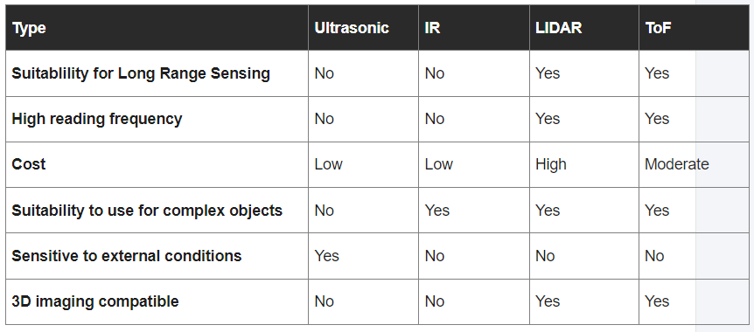

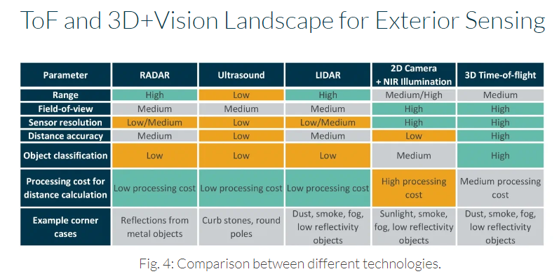

*Time-of-Flight Distance Sensor:*

**Pros:**

* High measurement range
* High measurement accuracy
* Compatible with 3D imaging
* Able to identify large objects
* Possesses a high field of view
* High sensor resolution
* Relatively low cost
* High reading frequency
* Suitable to measure complex objects

**Cons:**

* Z-depth resolution is poor
* suffers from smoke, fog, dust, and low-reflectivity objects
* Medium processing cost

*LiDAR Distance Sensor:*

**Pros:**

* High measurement range
* High measurement frequency
* Compatible with 3D imaging
* Suitable to measure complex objects
* Low processing cost
* Decent Z-depth resolution

**Cons**:

* High cost
* suffers from smoke, fog, dust, and low-reflectivity objects
* Low sensor resolution
* Low field of view

**Camera**

The drone camera allows the user to get a first-person view of what the drone is seeing such that it allows them to get an understanding of the situation at hand. We require a camera on the drone that has a high enough resolution to allow for a clear view of the drone’s surroundings while also being compact and light enough to not hinder the drone’s performance. We were deciding between a small compact camera for general use and a specialized FPV drone camera that had an antenna built into it.

*Regular Camera:*

**Pros:**

* Very high resolution

**Cons:**

* Heavy
* Needs and external antenna
* Bigger size compared to other camera choice
* Higher cost

*Drone FPV Camera:*

**Pros:**

* Lightweight
* Built-in antenna
* Easy to use and integrate with the drone
* Low cost

**Cons:**

* Lower resolution compared to other choice

**DIY Drone Kit:**

Allows for easy mounting on, and addition to, the drone body without the need to destroy or modify the existing body. We chose a drone kit because it allowed for a cost-effective way to add our hardware to an already existing and working drone allowing us to focus on the glove control and sensor integration.

**Microcontroller (ATMEGA 328 chip):**

The use of a microcontroller chip allows for easy integration between the sensors and the drone. This chip is used because we have previous experience and knowledge of how it works and programming and working with it. It will serve as the brains of obstacle detection and avoidance and will interface directly with the drone to execute obstacle avoidance measures.

In the hardware design process, careful consideration will be given to selecting appropriate components, determining optimal values for different elements, and ensuring the overall integration aligns with project requirements. This involves a balance between functionality, user experience, and practicality to create a reliable and user-friendly glove-based

control system for our smart drone.

## Software Design

### 5.2.1 Glove Software

The objective of the glove-based control system is to integrate the glove hardware with additional software in order to reach the desired goals for the drone. This system works by capturing intuitive hand movements through accelerometers and gyroscopes integrated into the glove. Then the software will translate those sensor inputs into commands for the drone. The goal is to develop a seamless control system that simplifies drone operations for first responders while also allowing the user to have one hand free.

**Functionality**

The commands for the drone will be based on intuitive hand movements. The left and right commands will be based on the user moving their hand left and right, as shown in *Figure 10 (a)*. In order to move forward the user will tilt their hand down and to move backwards the user will tilt their hand upwards, as shown in *Figure 10 (b)*. Then the flex sensor on the user's finger will be controlling the throttle as well as the movements up and down, as shown in *Figure 10 (c)*.

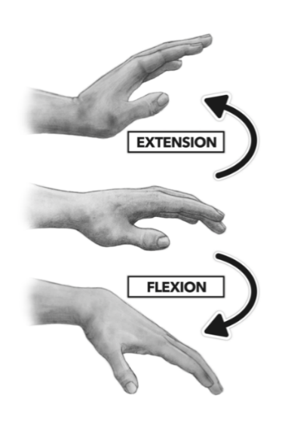

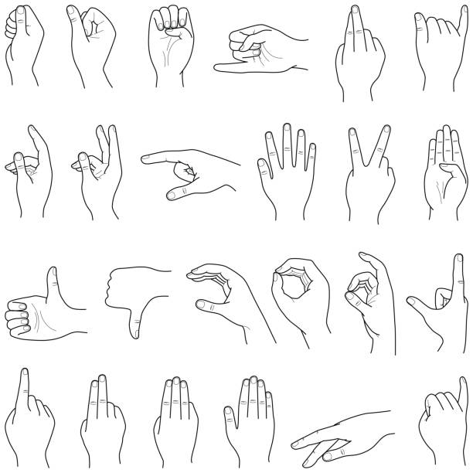

*(a)*

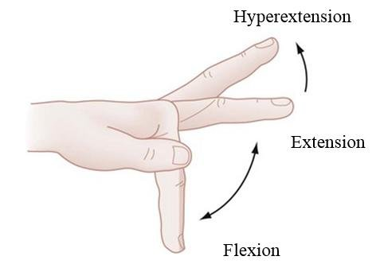

*(b)*

*(c)*

*Figure 10: Hand Motions Diagram*

**Design Choice: Addressing Accelerometer/Gyroscope Noise**

*Options 1: Filtering Noise*

**Pros:**

* + Effective noise reduction

**Cons:**

* + Difficulty in calibration
  + There is a tradeoff between the noise reduction and the responsiveness due to increased computational load
  + Blurring effect which is not suitable for incorporating thresholding
  + Parameter sensitivity that could lead to over or under-smoothing

*Option 2: Sample Data and Thresholding*

**Pros:**

* Real-time detection, lower computational load compared to filtering

**Cons:**

* Initially more time consuming to take samples
* Threshold selection

Design Decision

Based on the pros and cons of each choice it seems that sampling data and thresholding is more advantageous than the filtering techniques that apply to this project. The main reason for this is because filtering can cause a delay due to computational load, which will decrease the responsiveness of the drone which is an essential part of this design. It is critical that the drone and user are able to have a seamless relaying of data with each other. This approach will be suitable and more effective for abrupt changes without the need for complex signal processing algorithms which can be more difficult to interpret and modify.

# System Test and Verification

## Software Systems

#### Accuracy of HUD

* + Measured by a known input from the sensors to see if the output correctly displays the warning

#### Accuracy of obstacle avoidance

* + Measured by moving an object at a known distance toward the drone until it autonomously tries to avoid collision

## Hardware Systems

#### Accuracy of distance sensor output

* + While attached to the drone in flight is measured by placing an object at measured distances from the drone and seeing the output

#### Accuracy and latency of the glove control input

* + Given a specific input from the glove observe the seen output of the drone
  + Measure the time between movement from the user to response by the drone
  + Observe if the desired movement by the drone was made

#### Flight time

* + Measure how long the drone stays in flight and how long a singular battery charge lasts

# Team

The workload for this project has been divided into four modules, where two modules are primarily concerned with the drone while the other two focus on the glover controller. Each team member is assigned a module such that the drone and glove controller each have an EE and a COE working on them. The EEs are tasked with working on the hardware and PCB designs while the COEs focus on the software and coding portions.

## Seth Nordeen

Seth Nordeen is an Electrical Engineering specializing in autonomous systems and embedded circuits. Seth’s role in the team is interfacing with the drone, camera, and sensors. The drone will interface with sensors that will be mounted on top of it for obstacle detection and avoidance. The drone will also have a camera mounted to stream a live video feed directly to the user.

### 7.1.1 Skills learned in ECE coursework

ECE 0201 supplied the knowledge of digital circuit design allowing for an understanding of the design of interfacing the drone with the sensors and camera. ECE 0202 supplied the knowledge of interfacing with microprocessors and interfacing with sensors allowing for the understanding of the interaction between the drone and the sensors. ECE 0402 supplied knowledge of signal processing, allowing for the understanding of how the sensors interact with the world and the data they transmit. ECE 1885 supplied the basic understanding of hands-on techniques required for creating an interface between the drone and the sensors. ECE 1895 supplied the knowledge of interfacing with microcontrollers and prototyping and designing a project from the ground up.

### 7.1.2 Skills learned outside ECE coursework

Seth has prior experience with building and flying drones. He also has experience in interfacing with distance sensors, specifically ultrasonic sensors, in autonomous robotic kits. Seth also has experience in 3D modeling and 3D printing. These previous experiences will aid Seth in his role of creating a way for the drone to interface with the glove controller, the sensors, and the camera.

Seth acknowledges gaps in his knowledge and understands what he will have to research for this project. A few examples of what he needs to research are the best drone design, the best type of distance sensor, how drone cameras transmit live video wirelessly as well as which is the best option for the project, and how drone flight controllers operate to accomplish a desired outcome.

Seth plans to consult with faculty to discuss potential questions or difficulties that could arise in the project. Some such faculty members would be Professor Dickerson for general advice and colleagues of his that he believes could assist us. He also plans to ask Professor Mao about any control-related questions that may arise. He also plans to ask the faculty of SERC, such as Jim Lyle and William McGahey, for drone advice, prototyping, electrical components, or simple questions that may arise. Finally, Seth also plans to ask his peers for advice or insight into any problem or question he might encounter to establish a different outlook or idea that could have been overlooked or not thought about.

## Karey “KJ” Stone

Karey "KJ" Stone, an electrical engineering major with a focus on nanotechnology, plays a pivotal role in Group A's Smart Drones project. Specifically, she is tasked with designing the control glove for the FPV drone, serving as the interface for user commands through hand gestures and movement.

### Skills learned in ECE coursework

KJ's educational background and skills align seamlessly with the demands of this challenging assignment. In her ECE coursework, she gained expertise in digital circuit design through ECE 0202 - Digital Circuits and Systems, laying the foundation for understanding the electronic components crucial to the glove's development. Further, ECE 0302 - Microelectronic Circuits equipped her with essential knowledge for comprehending the microelectronics integral to sensor integration, a key aspect of the glove's functionality. The skills acquired in ECE 0402 - Embed Processors Interfacing are vital, involving a deep understanding of embedded processors, which is crucial for seamlessly interfacing the glove with the drone's control system. Her hands-on experience in electronic circuit design, acquired through ECE 1885 - Electronic Circuit Design Lab, directly applies to the creation of the glove. Additionally, participation in ECE 1895 - Junior Design Fundamentals provided her with knowledge of design methods, familiarity with the Atmega microchip, programming an OLED screen, and the experience of independently executing a project – all essential for her role in crafting the glove for the Smart Drones project.

### 7.2.2 Skills learned outside ECE coursework

KJ's skills extend beyond her formal coursework. Holding an apprentice mechanical drafting license and possessing years of 3D printing experience from high school, she brings valuable prototyping expertise to the team. Looking ahead, KJ is proactive in recognizing the need for further learning to contribute effectively to the project. Her future learning strategies involve independent research on topics such as drone remote operation, circuit creation using gyroscope and accelerometer inputs, power and weatherproofing considerations for glove components, component selection, prevention of overheating, appropriate glove types, and communication between the drone camera and a separate screen.

Acknowledging the complexity of the Smart Drones project, KJ emphasizes the importance of seeking external expertise. She plans to consult with faculty members specializing in sensor integration and wireless communication, intending to approach Professor Dickerson for insights on potential experts within the faculty. Collaborations with Professor Shankar on materials and Professor Chen on laser-related aspects will enrich KJ's knowledge further. Additionally, seeking advice from her friend Wesley, a member of the second drone group, reflects KJ's commitment to fostering collaboration and support within the project team, ensuring a comprehensive and well-informed development process for the glove interface.

## Berfin Bircan

Berfin Bircan is a computer engineering major who is responsible for the software behind the control glove for the FPV drone. This glove will be required to communicate with the software of the drone. It is vital that the glove software is able to accurately get data from the accelerometer and gyroscope on it, as well as the sensor data from the drone itself.

### 7.3.1 Skills learned in ECE coursework

Berfin has previous experience with aspects of this project from her previous coursework in the ECE department. The two classes that will be of use for the coding environments is both Junior Design Fundamentals as well as Hands On System Design and Engineering. These will be helpful because they exposed her to the ATMega chip as well as accelerometers and gyroscopes. Along with this she has taken Signals, Systems, and Probability which will be useful for any filtering that will be needed. Along with this she has also taken Introduction to Machine Learning which will be useful if there is any algorithms that will need to be utilized for interpreting the data.

### Skills learned outside ECE coursework

Berfin is aware of the skills she will be required to research and learn more about throughout this project. Overall, she will need to look into drones, how they are usually controlled, and how the remote control communicates with the drones. Another topic she will need to do more research for is the best way to communicate live video feeds wirelessly, for example whether communicating through radio frequencies or over Wi-Fi is better. She will also need to do research online, as well as thorough testing, with how different gestures will translate to values controlling the different motors as well as how to deal with any noise that disrupts the values.

She is aware that this is a complex project and as a result Berfin acknowledges that she will need to ask for advice from others including William McGahey and Jim Lyle, who work at SERC, as well as Dr. Dickerson for advice about drones since two of them are on the drones’ board. Along with this, she will need to find and learn from any professors that have experience in wireless communications, specifically with live video feeds. She also plans on speaking with Dr. Samosky for any advice regarding any and hardware to software relations, as well as any advice regarding human centered design specifically regarding this project. Finally she will talk to Professor Akcakaya and Professor Dallal about filtering as well as machine learning algorithms for the accelerometer and gyroscope data.

## Cassandra Oliva Pace

Cassandra Oliva Pace is a computer engineering major specializing in autonomous systems. She is responsible for the software development that is associated with the drone itself. This includes the software to implement the desired drone movements according to the glove controller, the implementation of accurate system responses given data from distance sensors for obstacle detection and avoidance, and the visual feedback as heads-up display on the screen.

### 7.4.1 Skills learned in ECE coursework

Most of the knowledge and skills required to complete her corresponding module have been learned from a variety of ECE courses throughout her academic career. In particular, Junior Design Fundamentals, Problem Solving with C++, Systems and Project Engineering, and Image Processing and Computer Vision. Junior Design Fundamentals introduced Cassandra to the ATMega328, which is the microcontroller that will be used on the drone. She learned to use the Arduino IDE to communicate with a barebones ATMega328, which she will have to do again in this project. In Problem Solving with C++, Cassandra learned the basics and fundamentals of the C++ language and had extensive practice coding many programs with different functionalities. Most of the software required for this project will be written in C/C++ within the Arduino IDE. Systems and Project Engineering exposed Cassandra to her first semester-long group project. Mainly of the teamwork, project/time management, and version control skills learned in that class can be directly applied to this project as it is also a semester-long group project. And lastly, Image Processing and Computer Vision taught Cassandra algorithms that she might need to apply for the visual cues and feedback on the heads-up display. Additionally, she is currently enrolled in Cyber-Physical Systems, where she is learning to program a microcontroller to interact with DC motors and distance sensors on a robot, which is almost exactly what will need to be done in this project, except on a drone.

### 7.4.2 Skills learned outside ECE coursework

Cassandra has extensive internship experience in firmware, which will directly benefit her role in this project as she will be writing software that will directly control the drone hardware. In addition, she is also aware that she will have to obtain skills and knowledge from other sources in order to effectively complete her module within the proposed drone system. This includes understanding the built-in flight controller that comes with the drone kit that will be utilized for this project. This will be done by understanding the data sheet found online for the specific flight controller so that she can communicate with it. She will also have to learn how to communicate with the distance sensors and understand how to display visual cues on the screen.

# Schedule and Budget Plan

## Project Schedule

**Timeline**

|  |  |
| --- | --- |
| Week 1 (1/14-1/20):  Project Kickoff and Planning | All members: Define project goals and success criteria. Set up communication channels within the team. Develop an in-depth project plan with details and milestones. Define which members are responsible for each module. |
| Week 2 (1/21-1/27):  Research | **All members**: Wrote their team sections as well as their other designated sections in the Conceptual Design Document.  **Glove Members**: Research and select suitable gyroscopes/accelerometers and any glove components.  **Drone Members**: Select or design the motor controller. Figure out the drone frame and electronics. |
| Week 3-4 (1/28-2/10):  Design | **All members**: Revise and finalize the Conceptual Design Document. Order the first set of parts.  **Berfin**: Write pseudocode, as well as begin basic coding for the glove, focusing on user input interpretation. Look into communication through transmitter/receiver to ensure clear communication of instructions, as well as receiving video feed.  **Cassandra**: Write pseudocode, as well as begin basic coding for the drone. Look into communication through transmitter/receiver for instructions as well as transmitting video feed.  **KJ**: Work on the design and functionality of the glove. Research on how to incorporate the flex sensor and LED indicator into the glove pin out.  **Seth**: Work on the design for the drone hardware for stable flight. Research about how to incorporate sensors into the drone.  ------------------------------------------------------------------------  **2/9 Conceptual Design Document Due (Try to have it done by February 2nd)** |
| Week 5-7 (2/11-2/24):  Prototype Part 1 | **Berfin**: Continue implementing the code for the glove and incorporate it with the hardware. Work on communication with the drone.  **Cassandra**: Continue implementing the code for the drone and incorporate it with the drone hardware. Work on communication with the glove.  **KJ**: Make a prototype and verify the glove’s electronic components and pin out. Create a PCB for the glove components to create a more seamless fit on the glove.  **Seth**: Make prototype the drone’s frame and electronics.  ------------------------------------------------------------------------  **2/19 and 2/21 First and Second Cohort Checkoff #1** |
| Week 7-8 (2/25-3/9):  Prototype Part 2 | **All members**: Continuously work on seamless integration of all 4 modules. Integrate microcontrollers and communication modules. Establish wireless communication between the drone and glove.  **Berfin**: Incorporate the flex sensor into the glove’s software. Develop collision avoidance algorithms. Develop collision avoidance algorithms. Establish wireless communication between the drone and glove.  **Cassandra**: Incorporate the obstacle detection sensors into the drone’s software.  **KJ**: Incorporate the flex sensor onto the glove hardware. Design controls on the glove.  **Seth**: Integrate obstacle detection sensors onto the drone’s hardware.  ------------------------------------------------------------------------  **3/4 and 3/6 First and Second Cohort Midterm Presentations** |
| Week 9 (3/10-3/16):  Spring Break | *\* Up to teammates if they want to work on anything over break \** |
| Week 10-11 (3/17-3/30):  Prototype Testing & Iteration | **All members**: Conduct individual tests for each component. Begin integration tests and user testing. |
| Week 12-13 (3/31-4/13):  Integration & Finalization | **All members**: Integrate the finalized drone and glove components into a cohesive system. Test the complete system to ensure seamless interaction. Finalize the design and make necessary adjustments based on testing. Document the design, code, and any specific configurations. Prepare user manuals for both the drone and the glove.  ------------------------------------------------------------------------  **4/1 and 4/3 First and Second Cohort Checkoff #2** |
| Week 14 (4/14-4/20):  Presentation | **4/15 and 4/17 First and Second Cohort Final Presentations**  **4/18 Swanson School Design EXPO** |

## Project Budget

Below are all the necessary items for the Smart Drones project. Our design budget is over the allotted $200 with the additional parts being $154.28 and the price for the drone being $255.88. The grand total will be $410.16 for the entire design and the additional funding will enable us to acquire the drone as well as the necessary sensors and components to allow for a seamless hands-free drone system for first responders to utilize in crucial situations.

Parts for the Drone:

* Gyroscope and Accelerometer
* Screen Receiver
* Radio Transmitter and Receiver
* Camera
* Drone Motors
* Drone Propellors
* Drone Sensors (x6)
* Drone Lipo battery
* Drone Frame
* motor controller
* Flight Controller
* Microcontroller
* GPS
* Power Management Module
* Drone
* LCD screen

Parts for the Glove:

* Power Adapter for Radio Transmitter
* Radio Transmitter and Receiver (with or without antenna)
* Gyroscope and Accelerometer
* ATMega microcontroller (x5)
* Battery Holder
* 9V Battery
* Glove
* Flex Sensor

## Minimum Standard for Project Completion

The minimum standard that our project must meet is having a glove that can control the drone’s movements remotely. We will use gesture controls to move the drone forward, backward, left, and right. We will fly the drone at a fixed height with no ability to go upwards or downwards. We will have the drone stream a live video to a stationary HUD that has indications when in proximity to an obstacle. Distance sensors will be on each face such that the drone can detect obstacles from any direction. They will detect an object from a specified distance to begin alerting the user on the HUD until a threshold is reached such that the drone takes over to avoid collision.

## Final Demonstration

We plan to demonstrate the accuracy of obstacle detection by getting the sensor data and measuring the distance to a measured surface. We plan to test the accuracy of the HUD by putting obstacles at a measured distance from the sensors and recording the display on the HUD compared to the desired output. We also plan to demonstrate the success of obstacle avoidance by testing how close a surface can come to the drone before it acts autonomously to avoid collision. We also plan to test the glove’s accuracy and latency in controlling the drone by making a motion of the glove, measuring the response time, and confirming the correct action has been made by the drone. We also plan to measure the latency of the live video feed by putting an object in the frame and measuring how long it takes for the object to appear on our video feed. All our data from testing will be presented through video demonstrations.

# References

“Roll, Pitch, and Yaw | How Things Fly.” Howthingsfly.si.edu, howthingsfly.si.edu/flight-dynamics/roll-pitch-and-yaw#:~:text=Rotation%20around%20the%20front%2Dto.

Mercer, Marsha. “States Strive to Reverse Shortage of Paramedics, EMTs.” Stateline, 6 Feb. 2023, stateline.org/2023/02/06/states-strive-to-reverse-shortage-of-paramedics-emts/.

Goodrich, Ryan. “Accelerometer vs. Gyroscope: What’s the Difference?” Livescience.com, 31 May 2018, www.livescience.com/40103-accelerometer-vs-gyroscope.html#:~:text=Using%20the%20key%20principles%20of. Accessed 10 Feb. 2024.

Admin_Terabee. “Time-of-Flight Principle (ToF): Brief Overview, Technologies and Advantages.” Terabee, 3 Feb. 2022, www.terabee.com/time-of-flight-principle/#:~:text=All%20Time%2Dof%2DFlight%20(. Accessed 10 Feb. 2024.

ARDUINO TEAM. “Control Your DIY Quadcopter with One Hand.” *Arduino Blog*, 3 June 2016, blog.arduino.cc/2016/06/03/control-your-diy-quadcopter-with-one-hand/. Accessed 8 Feb. 2024.

“ATMega328P Microcontroller Pinout, Pin Configuration, Features & Datasheet.” *Components101.com*, 2018, components101.com/microcontrollers/atmega32 8p-pinout-features-datasheet. Accessed 8 Feb. 2024.

“Circuit Playground Bluefruit: Advanced Bluetooth LE Microcontroller for DIY Projects.” *Www.electromaker.io*, www.electromaker.io/shop/product/circuit-playground-bluefruit-bluetooth-low-energy?gad_source=1&gclid=CjwKCAiAkp6tBhB5EiwANTCx 1I5bQu3GSjVApSBKaPvT1kHMHjVK1iYfJWCa72_rBCv2MzbgvE0rNRoCG7oQAvD_BwE. Accessed 8 Feb. 2024.

Click Science. “How to Make a Gesture Controlled Drone.” *Www.youtube.com*, 25 Mar. 2021, www.youtube.com/watch?v=hR1zRQ4YVQM. Accessed 8 Feb. 2024.

“Flex Sensor.” *Components101*, 18 Mar. 2018, components101.com/sensors/flex-sensor-working-circuit-datasheet.

Jimblom. “Flex Sensor Hookup Guide - Learn.sparkfun.com.” *Sparkfun.com*, 2016, learn.sparkfun.com/tutorials/flex-sensor-hookup-guide/all. Accessed 8 Feb. 2024.

“MPU-6050 GY-521 3-Axis Accel & Gryo Sensor Module.” *ProtoSupplies*, protosupplies.com/product/mpu-6050-gy-521-3-axis-accel-gryo-sensor-module/. Accessed 8 Feb. 2024.

“NRF24L01 Breakout Adapter with Voltage Regulator.” *ProtoSupplies*, protosupplies.com/product/nrf24l01-breakout-adapter-with-voltage-regulator/. Accessed 8 Feb. 2024.

“NRF24L01+PA+LNA 2.4GHz RF Wireless Module.” *ProtoSupplies*, protosupplies.com/product/nrf24l01palna-2-4ghz-rf-wireless-module/. Accessed 8 Feb. 2024.

Zhang, P. (2010). Chapter 3 - Sensors and actuators. In *Advanced Industrial Control Technology* (pp. 73–116). essay, William Andrew Publishing. Retrieved February 9, 2024, from <https://www.sciencedirect.com/science/article/pii/B9781437778076100038>.

Shawn. (2021, June 29). Types of distance sensors and how to select one?. Latest Open Tech From Seeed. <https://www.seeedstudio.com/blog/2019/12/23/distance-sensors-types-and-selection-guide/>

Why choose time-of-flight for your Automotive 3D Sensing Applications. Melexis. (n.d.). <https://www.melexis.com/en/tech-talks/why-choose-time-of-flight-for-your-automotive-3d-sensing-applications#:~:text=Compared%20to%20ToF%2C%20high%2Dresolution,resolution%20and%20lower%20depth%20accuracy>.